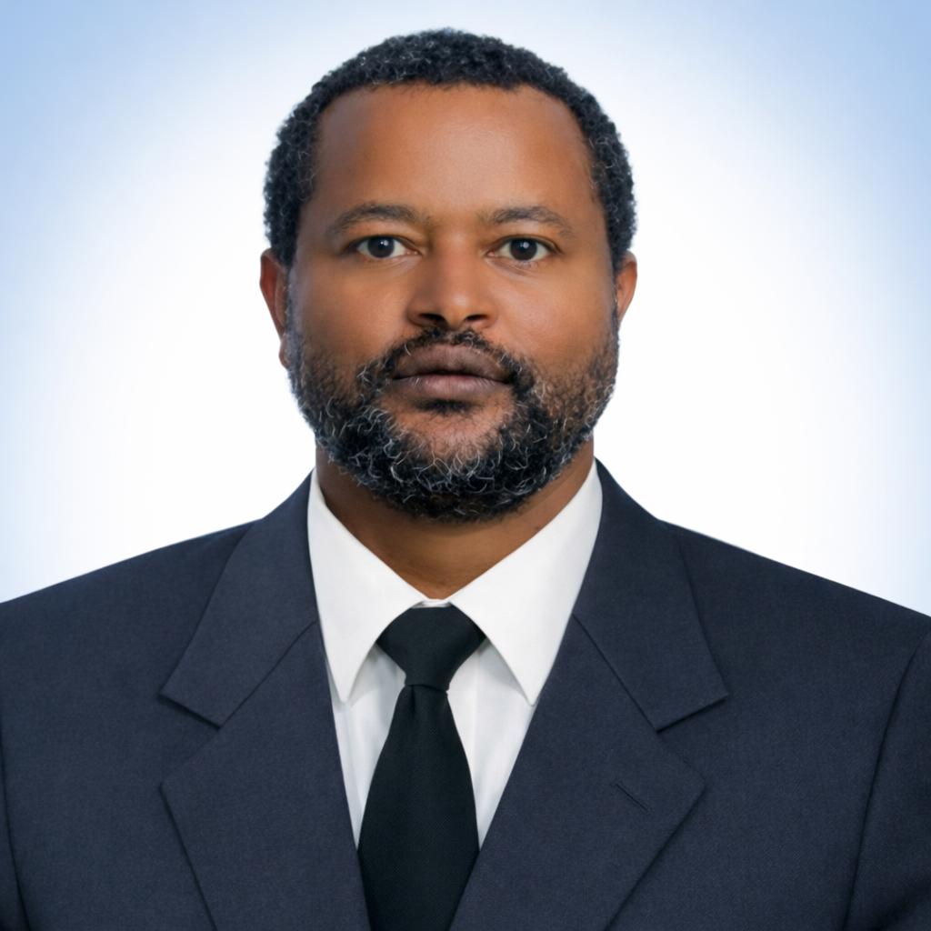 | CONSULTANT PROFILE  Yosef Tafa Oba  Senior Engineering Geologist | Geotechnical Engineer | Material Engineer  Senior engineering geologist with over 15 years of professional experience in geotechnical investigations, materials engineering, hydrogeology, geological mapping, foundation assessment, dam-related site investigation, and infrastructure project support. His background combines strong field investigation skills, laboratory coordination, construction material evaluation, geotechnical interpretation, and technical reporting for dams, bridges, roads, buildings, and water infrastructure projects.

M.Sc. in Geological Engineering | B.Sc. in Applied Geology
Dam & Geotechnical Investigation | Hydrogeology & Materials Engineering
Executive Summary
Yosef Tafa Oba is a senior engineering geologist with extensive experience in geotechnical site investigation, geological and geotechnical mapping, materials sourcing, laboratory and field testing coordination, hydrogeological assessment, and foundation investigation for major infrastructure projects. His work spans dams, bridges, roads, wastewater facilities, hydropower schemes, and building projects.
His professional experience is particularly relevant to dam and irrigation development, detailed geotechnical investigation, engineering geology for design support, construction material identification and quality control, in-situ testing, drilling supervision, technical interpretation of field and laboratory results, and preparation of factual and geotechnical design reports.
Strong geotechnical consultancy depends on sound field investigation, disciplined logging and testing, proper interpretation of site conditions, and the ability to convert investigation findings into practical design and construction guidance.

Areas of Professional Strength
Yosef Tafa Oba’s profile reflects broad experience in engineering geology, geotechnical investigation, construction materials engineering, hydrogeology, foundation assessment, and infrastructure project support. He has contributed to feasibility and detailed design assignments for dams, bridges, roads, wastewater treatment facilities, hydropower works, and public infrastructure projects in Ethiopia.
Core Areas of Expertise  - Geotechnical site investigation and foundation assessment  - Engineering geological mapping and structural interpretation  - Construction material sourcing and quality control  - Dam foundation investigation and borrow/quarry evaluation  - Hydrogeological investigation and groundwater assessment  - In-situ testing, borehole logging, and drilling supervision  - Laboratory test coordination and interpretation  - Technical reporting and geotechnical documentation | Professional Roles  - Senior Engineering Geologist  - Geotechnical Engineer  - Material Engineer  - Hydrogeologist  - Exploration Geologist  - Site Investigation and Reporting Specialist

Geotechnical, Geological, and Materials Engineering Expertise
- Foundation investigation for dams, buildings, bridges, and hydraulic structures.
- Engineering geological and geotechnical mapping of project sites and surrounding formations.
- Supervision of drilling works and logging of geological and geotechnical boreholes.
- Execution and interpretation of in-situ tests including SPT, CPT, DCP, permeability tests, and selected strength tests.
- Sampling of soil, rock, and water, with coordination of required laboratory testing.
- Identification and evaluation of construction material sources, including borrow pits and quarry sites.
- Quality control support for soils, aggregates, concrete materials, and related engineering inputs.
- Assessment of unstable slopes, erosion-prone sections, and landslide-affected areas, with practical recommendations.
- Hydrogeological investigation, groundwater resource assessment, and water quality-related mapping.
- Preparation of factual reports, interpretive geotechnical reports, and engineering documentation for design teams and project implementation.

Core Technical Strengths
Engineering Geology | Geotechnical Investigation | Dam Foundation Studies
Material Engineering | Hydrogeology | Borehole Logging
SPT / CPT / DCP | Permeability Testing | Borrow & Quarry Studies
Construction Materials | Groundwater Assessment | GIS & Remote Sensing
Technical Reporting | Field Supervision | Laboratory Coordination

Professional Profile
FULL NAME  Yosef Tafa Oba | NATIONALITY  Ethiopian | DATE OF BIRTH  September 1984
EMAIL  yoseftafa@gmail.com | ALTERNATIVE EMAIL  yoseftafa@yahoo.com | PHONE  +251 911 802 658

Education
Addis Ababa University, Ethiopia
2021
Master of Science in Geological Engineering.
Research work: Characterization of Embankment Material with special consideration to Clay Core: A Case Study for Kalid-Dijo Dam in Southern Ethiopia.
Mekelle University, Ethiopia
2007
Bachelor of Science in Applied Geology.
Kersa High School, Harer, Ethiopia
2002
High School Education.

Professional Registration and Certifications
Professional Registration  - Registered Practicing Professional Geological Engineer — Ethiopian Construction Authority (524/2022)  - Registered Graduate Hydro-Geologist — Ministry of Water, Irrigation and Energy of Ethiopia (DGG/156) | Selected Training  - Designing and Construction, Surveying, AutoCAD, Material Testing, Construction Management, and Guidelines  - GIS and Remote Sensing applications for geological mapping, material resource exploration, geo-hazard mapping, and water resources  - Basic Geosciences and Mapping, material exploration, groundwater resource assessment, geophysical methods, laboratory and drilling application  - Project management, business planning, financial planning, artificial intelligence fundamentals, machine learning, and data analysis fundamentals

Selected Career Highlights
More Than 15 Years of Progressive Experience  Extensive experience across engineering geology, geotechnical investigation, hydrogeology, construction materials engineering, and infrastructure project support in Ethiopia. | Strong Dam and Infrastructure Investigation Background  Contributed to numerous dam, hydropower, bridge, road, wastewater, and building-related investigations from feasibility through detailed design stages.
Balanced Field and Office Experience  Combines field investigation, drilling and testing supervision, data interpretation, report preparation, and engineering support for multidisciplinary design and supervision teams. | Materials and Hydrogeology Exposure  Brings added value through experience in groundwater investigation, mineral and material resource exploration, construction material evaluation, and water-related geological mapping.

Employment Record
Ethiopian Engineering Corporation
March 2016 – Present
Senior Engineering Geologist responsible for geotechnical and geological investigation support for dam, bridge, wastewater, hydropower, and building projects.
Jamma Rural Road Construction Pvt. Ltd.
January 2012 – March 2016
Materials Engineer responsible for soil and material investigation, pavement support, borrow and quarry assessment, concrete mix design support, and field and laboratory quality control.
Gondwana Engineering Plc
October 2011 – January 2012
Engineering Geologist contributing to geotechnical investigation and foundation-related engineering support.
Ursuta Industrial Minerals Producer Plc
June 2010 – October 2011
Exploration Geologist involved in geological mapping, mineral exploration, core logging, field sampling, and technical reporting.
Geological Survey of Ethiopia
May 2008 – June 2010
Hydrogeologist involved in groundwater resource assessment, hydrochemical evaluation, hydrogeological mapping, and well-related field support.
Anuar Ibrahim General Contractor
August 2007 – May 2008
Engineering Geologist supporting building construction material investigation and quality control.

Experience Relevant to Dam and Geotechnical Investigation Projects
Dam Feasibility and Detailed Design Investigation Support
Participated in geological and geotechnical investigation works for major dam and irrigation projects including Gindera Dam, Katar Dam, Sego Dam, Kalid-Dijo Dam, Weito Dam, and Tams Hydropower Dam.
Foundation and Site Characterization
Conducted foundation investigation, borehole logging, in-situ testing, drilling follow-up, and sample collection for dams, bridges, buildings, and treatment facilities.
Borrow Area and Quarry Assessment
Identified and evaluated potential construction material sources, including borrow pits and quarry sites, with support to quality control and engineering suitability assessment.
Interpretation and Reporting
Contributed to data analysis, interpretation of geological and geotechnical conditions, and preparation of factual and detailed geotechnical design reports for infrastructure projects.

Selected Project Exposure
Gindera Dam Project
Geotechnical investigation support for feasibility and detailed design.
Katar Dam Project
Geotechnical investigation support for feasibility and detailed design.
Kalid-Dijo Dam & Irrigation Project
Geological and geotechnical investigation support relevant to embankment material characterization and design studies.
Sego Dam & Irrigation Project
Engineering geological and geotechnical investigation support for feasibility and detailed design.
Weito Dam Project
Geological and geotechnical investigation support for dam-related design work.
Tams Hydropower Dam Project
Geological and geotechnical investigation support for hydropower dam feasibility design.
Koye Fetche Waste Water Treatment Plant Site
Geotechnical investigation support for feasibility and detailed design.
Bridge, Road, and Building Projects
Contributed to bridge, road, apartment building, and public facility investigations involving geotechnical, materials, and foundation-related inputs.

Representative Responsibilities
- Follow-up of drilling progress and field investigation programs.  - Geological and geotechnical borehole logging.  - Collection of disturbed and undisturbed samples.  - Coordination of soil, rock, concrete, and water testing.  - Execution and recording of in-situ tests and field observations.  - Engineering geological and geomorphological mapping. | - Interpretation of field and laboratory data for engineering objectives.  - Assessment of problematic sections including poor subgrade, erosion, drainage, and landslide-prone areas.  - Investigation of construction materials for roads, bridges, dams, and buildings.  - Quality control support for aggregates, soils, concrete, and related materials.  - Preparation of geotechnical, materials, and hydrogeological reports.  - Support to project teams through technical reporting and engineering documentation.

Representative Project Experience
Project | Role | Client / Institution | Relevant Experience
Gindera, Katar, Sego, Kalid-Dijo, Weito, and Tams Dam Projects | Engineering Geologist / Senior Engineering Geologist | Ethiopian Engineering Corporation / Water sector clients | Dam-related geotechnical and geological investigation support, borehole logging, field testing, materials assessment, and reporting for feasibility and detailed design.
Koye Fetche Waste Water Treatment Plant Site | Engineering Geologist | Relevant public institution | Geotechnical investigation support for treatment plant site evaluation and design input.
Road and Bridge Construction Projects in Amhara Region | Materials Engineer | ARA / Road sector assignments | Materials investigation, pavement-related support, borrow and quarry studies, field and laboratory control, and soil/material reporting.
Hydrogeological Investigation and Mapping Assignments | Hydrogeologist | Geological Survey of Ethiopia / Ministry-related programs | Groundwater assessment, hydrochemical interpretation, regional mapping, water quality mapping, and well-related field support.

Languages
AMHARIC  Native | AFAAN OROMO  Very Good | ENGLISH  Excellent

Selected Personal Interests
Reading | Research | Problem-Solving | Family Support

References
Mr. Berhane Yadessa
Deputy Chief Executive Officer, Ethiopian Engineering Corporation
Phone: +251 913 427 630
Mr. Ashenafie Tesfaye
Geological and Geotechnical Investigation Process Manager, Ethiopian Engineering Corporation
Phone: +251 923 671 731
Mr. Habtamu Solomon
Geotechnical Investigation Sub-Process Manager, Ethiopian Engineering Corporation
Phone: +251 911 872 543

Professional Value
Yosef Tafa Oba offers a strong combination of engineering geology, geotechnical investigation, hydrogeology, materials engineering, field supervision, and reporting discipline that is highly relevant to dam, infrastructure, and construction-related consultancy assignments. His profile is especially suitable for projects requiring reliable site characterization, geotechnical interpretation, construction materials evaluation, and structured technical support from field investigation through reporting and design input.
Contact
Email: yoseftafa@gmail.com
Alternative Email: yoseftafa@yahoo.com
Phone: +251 911 802 658
Location: Addis Ababa, Ethiopia
Consultancy Role: Senior Engineering Geologist / Geotechnical Engineer / Material Engineer

