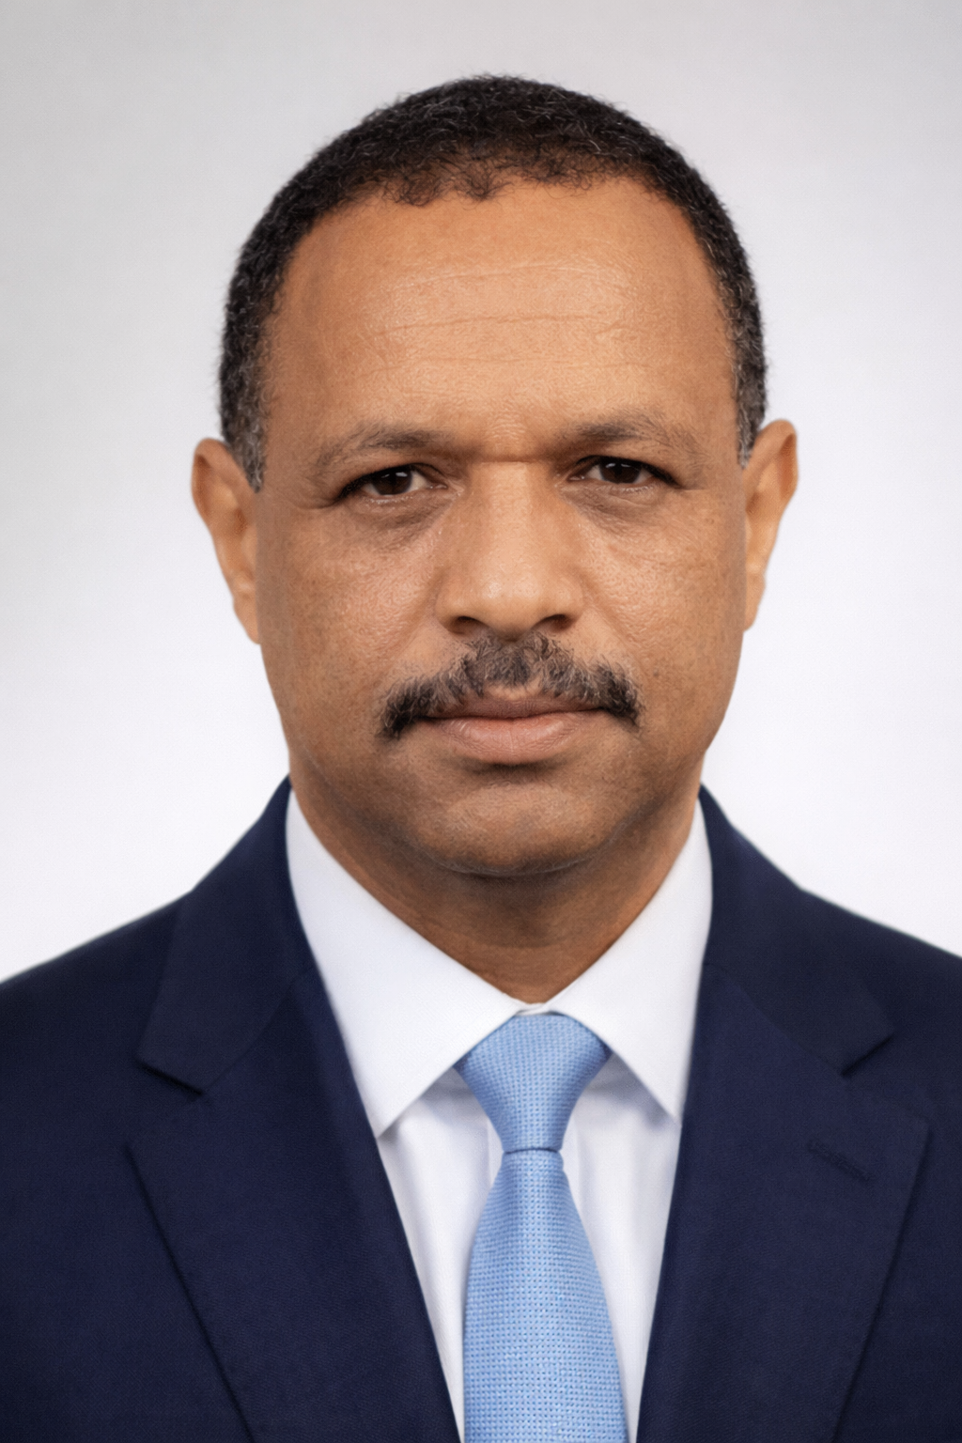
Consultant Profile
Mussie Abib Taddesse
Dam Safety Engineer | Team Leader | Dam Safety Management Specialist
Senior hydraulic engineer and dam safety professional with more than three decades of experience in dam engineering, hydraulic infrastructure, irrigation systems, hydrological and hydraulic assessment, construction supervision, dam rehabilitation support, operations and maintenance review, and multidisciplinary project leadership. His professional experience includes dam safety assessment, dam safety management systems, rehabilitation oversight, technical audit support, emergency preparedness planning, and institutional capacity building in complex water infrastructure programs.
M.Eng. in Hydraulic Engineering | B.Sc. in Water Engineering | Dam Safety & O&M Specialist | Team Leader / Project Manager

Executive Summary
Mussie Abib Taddesse is a senior hydraulic engineer with extensive experience in dam engineering, dam safety review, irrigation infrastructure, water resources development, hydraulic structures, construction supervision, project coordination, and technical leadership. His professional record combines public-sector, consulting, contractor-side, and institutional experience, giving him a strong practical understanding of how dam infrastructure is planned, reviewed, implemented, supervised, operated, and maintained.
His experience is particularly relevant to dam safety assessment, review of operation and maintenance arrangements, inspection planning, rehabilitation follow-up, technical reporting, institutional strengthening, and implementation support for dam safety management programs. He has worked on dams, irrigation systems, hydraulic structures, and major public infrastructure schemes across Ethiopia and has served in leadership roles involving multidisciplinary engineering teams, project coordination, and technical review.
Effective dam safety consultancy requires more than design knowledge alone. It demands field judgment, practical understanding of dam behavior, careful review of O&M systems, disciplined reporting, and the ability to convert engineering findings into practical risk-reduction actions.

Areas of Professional Strength
Mussie Abib Taddesse’s profile reflects broad experience in dam safety condition assessment, review of existing documentation and dam records, operations and maintenance evaluation, technical inspection of dams and appurtenant structures, review of spillway and outlet performance, rehabilitation planning support, supervision of remedial works, emergency preparedness review, and institutional strengthening for dam safety management systems.
Core Areas of Expertise  - Dam safety review and engineering evaluation  - Dam operation and maintenance review  - Hydrological and hydraulic assessment  - Spillway, outlet, reservoir, and appurtenant structure review  - Rehabilitation planning and implementation support  - Technical oversight and engineering supervision  - Dam safety reporting, inspection planning, and technical documentation  - Institutional strengthening and capacity-building support | Professional Roles  - Team Leader for dam safety and hydraulic infrastructure assignments  - Senior Dam Safety Engineer  - Dam Safety Management Specialist  - Rehabilitation Oversight Engineer  - O&M Review and Dam Inspection Specialist  - Dam Rehabilitation and Monitoring Coordinator

Dam Safety Engineering, O&M, and Rehabilitation Oversight Expertise
- Dam safety inspection and technical evaluation of embankment, concrete, and hydraulic structures.
- Review of dam operation and maintenance arrangements, inspection routines, and maintenance priorities.
- Hydrological and hydraulic safety assessment including reservoir behavior, flood routing, spillway adequacy, and outlet performance.
- Assessment of structural and operational deficiencies affecting dam safety and long-term performance.
- Review of instrumentation arrangements and monitoring systems, with engineering interpretation of performance trends where data are available.
- Preparation of dam safety recommendations, rehabilitation priorities, and technical action plans.
- Support to dam safety management program development, inspection frameworks, reporting systems, and emergency preparedness planning.
- Oversight of rehabilitation works through technical review, implementation follow-up, and quality-focused supervision.
- Technical audit support for dam safety performance, compliance review, and institutional improvement.
- Capacity building and mentoring support for dam operators, project teams, and technical staff.

Core Technical and Leadership Strengths
Dam Safety Assessment | Team Leadership | Dam Management Systems
Operations & Maintenance Review | Rehabilitation Oversight | Hydraulic Engineering
Hydrological Analysis | Spillway Capacity Review | Flood Routing
Reservoir Engineering | Inspection Planning | Monitoring Systems Review
Emergency Action Planning | Technical Audits | Capacity Building
Contract Administration | Technical Reporting

Professional Profile
Full Name  Mussie Abib Taddesse | Nationality  Ethiopian | Date of Birth  24 April 1972
Place of Birth  Addis Ababa, Ethiopia | Email  marengmuse@yahoo.com | Phone  +251 911 404 561

Education

International Institute for Infrastructural, Hydraulic and Environmental Engineering (IHE), Delft, The Netherlands
September 2002 – October 2003
Master of Engineering in Hydraulic Engineering

Arbaminch Water Technology Institute, Arbaminch, Ethiopia
September 1989 – July 1994
B.Sc. Degree in Water Engineering

Tikur Anbessa Secondary School, Addis Ababa, Ethiopia
September 1985 – July 1989
Ethiopian School Leaving Certificate in Natural Science

Selected Career Highlights
More Than 30 Years of Progressive Experience  Extensive professional experience across dam engineering, hydraulic design, project supervision, technical review, contract administration, irrigation infrastructure, construction monitoring, and large-scale public water sector programs. | Senior Leadership in Water Infrastructure  Held senior and lead roles across consulting, public institutions, design and supervision environments, development programs, and contractor-side project execution.
Strong Experience in Safety and Maintenance-Oriented Assignments  Experienced in condition assessment, O&M review, dam rehabilitation support, inspection systems, technical audit preparation, and dam safety program implementation. | Practical Multidisciplinary Coordination  Experienced in leading and coordinating engineering teams across dams, irrigation systems, hydropower-related infrastructure, water supply works, drainage, and institutional project delivery.

Employment Record

ECDSWC
September 2023 – Present
Dam Engineer and Project Manager in dam projects, including dam safety review, hydraulic assessment, project coordination, technical supervision, and support to project implementation.

Somali Plate Geoscience Consultant
February 2021 – August 2023
Project Coordinator for water supply and infrastructure design projects, with responsibilities in technical review, planning, coordination, and engineering management.

Afar Design & Supervision
December 2019 – January 2021
Senior Dam Engineer and Project Manager / Team Leader, responsible for dam engineering review, technical supervision, project leadership, and safety-related evaluation of hydraulic structures.

SESK Construction PLC
April 2018 – November 2019
Technical Manager and Project Manager overseeing infrastructure implementation, construction quality control, technical follow-up, and engineering coordination.

GIZ Ethiopia
November 2016 – March 2018
Project Officer and IWaSP Technology Officer supporting infrastructure development, water systems coordination, institutional project support, and technical management functions.

Ethiopian Sugar Corporation
June 2013 – April 2016
Project Coordinator and Project Manager for dam, irrigation, and hydraulic infrastructure components of major sugar development schemes, including engineering review, technical coordination, and implementation follow-up.

Water Works Design & Supervision Enterprise
June 2006 – June 2013
Dam Engineer, Project Manager, and Team Leader responsible for dam design, hydrological and hydraulic analysis, engineering review, and technical supervision of water infrastructure projects.

MCE Consult PLC / Kart Marine (UAE) / Freelance and Earlier Roles
1994 – 2006
Held successive technical and managerial roles including Supervisor, Team Member, Team Leader, Senior Design Expert, Hydraulic Engineer, Pipe Engineer, Department Head, and Project Supervisor Engineer.

Experience Relevant to Dam Safety Management and Maintenance-Oriented Projects

Dam Safety Review and Engineering Evaluation
Participated in the review, assessment, and technical evaluation of dams and associated hydraulic structures, including consideration of safety performance, hydraulic adequacy, operational risks, and engineering improvement needs.

Dam Operation, Maintenance, and Monitoring-Oriented Technical Review
Experience in reviewing hydraulic infrastructure performance, operational arrangements, inspection priorities, and maintenance-related engineering issues affecting long-term serviceability and safety.

Rehabilitation and Technical Follow-Up
Experience in design review, technical supervision, implementation oversight, and engineering management that is directly relevant to the follow-up of remedial works, review of intervention measures, and quality-focused rehabilitation oversight.

Institutional and Programmatic Support
Background in public-sector and development-oriented assignments supporting coordination, reporting, program implementation, technical management, and capacity strengthening in infrastructure institutions.

Relevant Dam Safety and Hydraulic Infrastructure Experience

Dam Safety Evaluation – Sugar Development Projects
Conducted engineering review and dam-related safety evaluation for hydraulic structures associated with major Ethiopian sugar development schemes, including Kesem, Kuraz, Wolkait, and Arjo-Didessa.

Arjo Irrigation Dam Project
Team Leader responsible for detailed engineering design review, hydrological and hydraulic assessment, and technical review of dam and appurtenant structures, including spillway and outlet works.

Wabi-Shebelle Multipurpose Water Development
Participated in feasibility studies and dam-related evaluation for multipurpose water resources development involving reservoir, irrigation, hydropower, and water supply components.

Dam and Irrigation Assignments in Multiple Regions of Ethiopia
Contributed to studies, design, review, supervision, and implementation support for dams, irrigation systems, drainage works, barrage structures, reservoirs, canals, and associated hydraulic infrastructure.

Representative Responsibilities Relevant to Dam Safety
- Review of design, construction, operation, and maintenance aspects of dams and hydraulic structures.
- Inspection and engineering assessment of dams, spillways, outlets, reservoirs, and appurtenant works.
- Hydrological and hydraulic review, including flood routing and spillway adequacy considerations.
- Identification of structural, hydraulic, operational, and maintenance deficiencies.
- Preparation of engineering recommendations for rehabilitation, risk reduction, and performance improvement.
- Technical support in reviewing dam instrumentation and monitoring arrangements.
- Project coordination and leadership of multidisciplinary engineering teams.
- Technical reporting, progress review, and engineering documentation.
- Support to the implementation of dam safety management procedures, inspection systems, and reporting frameworks.
- Oversight and follow-up of remedial works and rehabilitation measures.
- Support to Emergency Action Plan review and dam safety preparedness processes.
- Capacity building, mentoring, and institutional strengthening support for engineering personnel and project teams.

Key Responsibilities in Dam Safety Management and Maintenance Projects
- Review dam safety documentation, historical records, and technical reports.
- Assess the current safety condition of dams and related hydraulic facilities.
- Identify deficiencies in operation, maintenance, inspection, and monitoring systems.
- Review spillway, outlet, and reservoir-related hydraulic performance issues.
- Support the prioritization of remedial and rehabilitation measures based on engineering judgment and operational needs.
- Provide technical oversight during the implementation of dam rehabilitation and improvement works.
- Assist in the development of dam safety management procedures, inspection protocols, reporting tools, and institutional arrangements.
- Contribute to emergency preparedness review and site-specific action planning.
- Support technical audits, performance reviews, and corrective action tracking.
- Build institutional capacity through mentoring, workshop participation, and technical guidance.

Selected Project Exposure
- Erer and Gollolcha Irrigation Projects — Senior hydraulic and dam design involvement at feasibility and detailed study levels.
- Gumera Irrigation Projects — Dam and irrigation design expert at feasibility and detailed design stages.
- Arjo Irrigation Project — Team Leader responsible for finalization of detailed design for dam and appurtenant structures, hydropower, irrigation, and drainage systems.
- Wabi-Shebelle Multipurpose Water Resource Development — Feasibility-phase study support in dam design for hydropower, irrigation, and water supply purposes.
- Wolkait, Arjo-Didessa, Kesem, Kuraz, and Related Sugar Projects — Senior dam and hydraulic engineering roles involving design review, evaluation, supervision, project management, and technical follow-up of water infrastructure components.

Representative Project Experience
Project | Role | Client / Institution | Relevant Experience
Arjo Irrigation Project | Team Leader | Relevant Ethiopian public institution | Detailed design review of dam and appurtenant structures, hydrological and hydraulic assessment, technical leadership, and multidisciplinary coordination.
Wabi-Shebelle Multipurpose Water Resource Development | Dam Design / Feasibility Contributor | Relevant water sector institution | Dam-related feasibility support for hydropower, irrigation, reservoir, and water supply planning, with strong relevance to hydraulic and safety review.
Kesem, Kuraz, Wolkait, Arjo-Didessa Sugar Projects | Senior Dam and Hydraulic Engineering Specialist / Project Manager | Ethiopian Sugar Corporation / Related Programs | Design review, evaluation, implementation follow-up, engineering coordination, rehabilitation-oriented review, and risk-informed technical assessment.
Dam Engineering Assignments at Water Works Design & Supervision Enterprise | Dam Engineer / Team Leader | Water Sector Institutions | Dam design, hydraulic review, project supervision, technical documentation, and engineering leadership across water infrastructure assignments.

Training, Institutional Support, and Capacity Building
Mussie Abib Taddesse combines engineering practice with institutional and team-support experience relevant to dam safety capacity development, mentoring of technical personnel, support to inspection and reporting systems, and practical strengthening of dam management procedures. His experience in both project and institutional settings is valuable for assignments that require not only technical assessment, but also implementation, coordination, reporting discipline, and knowledge transfer.

Training and Professional Development
Additional professional development includes GIS and Global Mapping, MS Project, pressurized irrigation system design, drip and sprinkler systems, drilling equipment and pipe installation, water resources project design, geotechnical investigation, AutoCAD, and infrastructure planning workshops. These trainings complement his practical field and office experience across design, supervision, and project coordination environments.

Academic and Professional Contributions
Teaching Contribution  Delivered a course on Principles of Dam Engineering to fifth-year civil engineering students at Mekelle University. | Technical Papers  Presented papers on the causes of dam failures in limestone areas and leakage through dam embankment bodies, using case studies from the Mekelle area.

Professional Value in Dam Engineering and Safety Management
Mussie Abib Taddesse offers a combination of engineering depth, project leadership, public-sector understanding, implementation awareness, and practical field knowledge that is highly relevant to dam safety consultancy, rehabilitation oversight, operation and maintenance review, technical due diligence, dam safety management systems, inspection planning, and institutional capacity strengthening. His profile is especially suited to assignments that require a senior engineer who can combine technical review with practical implementation support and disciplined engineering judgment.

Contact
Email: | marengmuse@yahoo.com
Phone: | +251 911 404 561
Company: | Aqua Nile
Consultancy Role: | Dam Safety Engineer / Team Leader / Dam Safety Management Specialist

