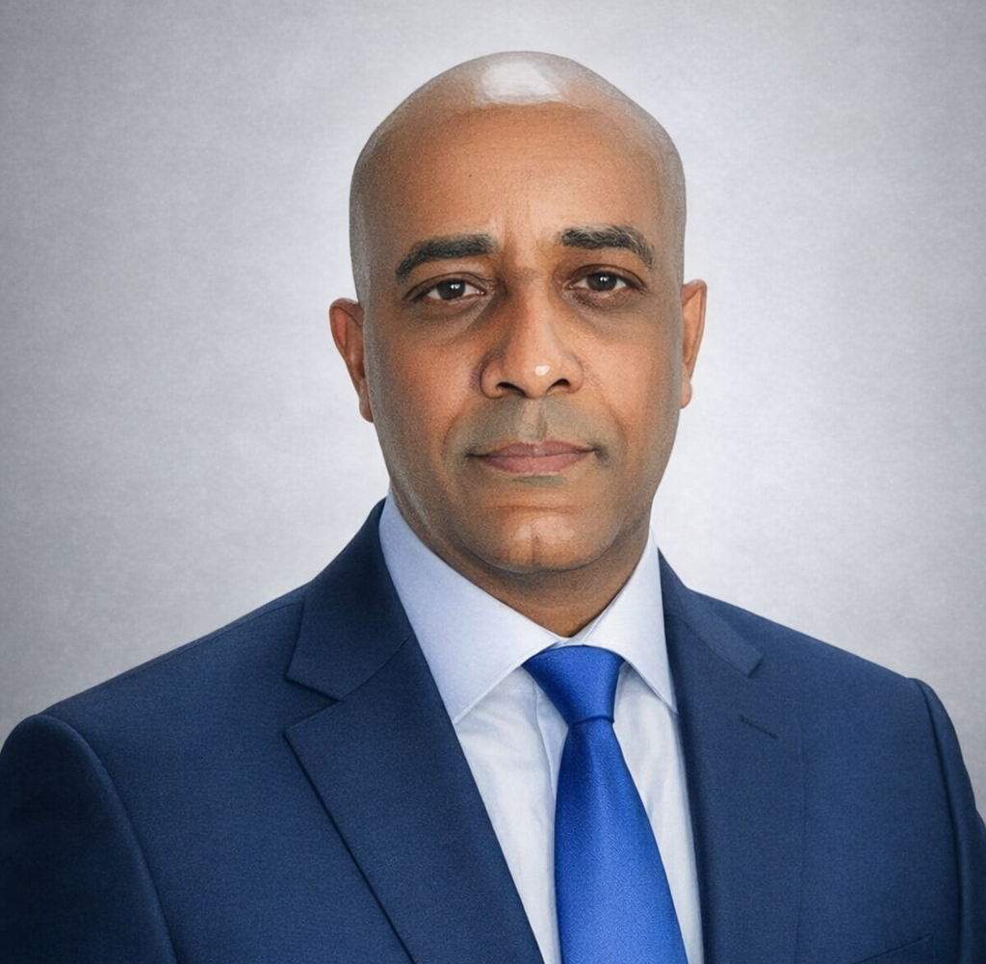
Consultant Profile
Mesfin Hagos Tewolde
Hydrologist | Civil Engineer | EUR ING | MPQ | SIA
Senior hydrologist and civil engineer with multidisciplinary experience in dam hydrology, design hydrology, flood routing, reservoir studies, water balance analysis, hydraulic and hydrologic modelling, irrigation and dam infrastructure, GIS, and technical reporting. His professional journey spans Eritrea, Ethiopia, South Africa, and Switzerland, combining field engineering, hydrological research, public-sector technical review, modelling, and independent consulting practice.
MScEng in Hydrological Engineering | BScEng in Civil / Irrigation Engineering | Postgraduate advanced study Certificate: urban Planning
Design Rainfall & Flood Hydrology | HEC-RAS / HEC-HMS / GIS | Reservoir Studies & Water Balance
Executive Summary
Mesfin Hagos Tewolde is a senior hydrologist and civil engineer with extensive practical and academic experience in engineering hydrology, design hydrology, flood routing, hydraulic and hydrologic modelling, reservoir studies, dam and irrigation infrastructure, GIS, remote sensing, and technical reporting. His profile combines field-based civil engineering, hydrological specialization, research collaboration, technical publishing, modelling discipline, and independent consultancy.
He holds a Master of Science in Hydrological Engineering from the University of KwaZulu-Natal, a BScEng in Civil / Irrigation Engineering from Arba Minch Water Technology Institute, and advanced postgraduate studies in urban planning through the Ecole Polytechnique Federale de Lausanne (EPFL) and the University of Geneva. He also pursued doctoral-level studies on two occasions: first in civil engineering-related research at the Central University of Technology in Bloemfontein, South Africa, and later at the University of Fribourg, Switzerland. Both doctoral paths were interrupted due to financial constraints. Over the years, he has contributed to hospital construction, small-scale earth dam construction, irrigation system development, hydrological research, flood analysis, river studies, reservoir-routing investigations, and catchment-based modelling exercises. His professional experience spans Eritrea, Ethiopia, South Africa, and Switzerland, including public-sector hydrology work in the Canton of Geneva, as well as advanced GIS and geomatics studies in Swiss academic institutions.
His experience is particularly relevant to assignments involving updated flood hydrology, design rainfall assessment, reservoir studies, dam-related hydraulic review, catchment-based water-resources analysis, and technically grounded reporting for infrastructure planning and safety-oriented decision-making.
“Effective engineering consultancy is shaped not by theory alone, but by field-tested understanding, disciplined modelling, careful judgment, practical supervision, and the ability to transform complex water challenges into clear, dependable solutions.”

Residence | Primary Email | Phone | Languages
Geneva, Switzerland | mtewolde@protonmail.com | +41 79 934 2970 | Amharic, Tigrigna, English, French
Areas of Professional Strength
Core Areas of Expertise  - Engineering hydrology and design hydrology  - Design rainfall estimation using Smithers and Schulze (2002)  - Flood routing in ungauged catchments  - Hydraulic and hydrologic modelling using HEC-RAS and HEC-HMS  - Reservoir routing, water balance analysis, and reservoir performance interpretation  - Catchment studies, discharge estimation, and flood hazard mapping  - SWAT-based catchment modelling and watershed analysis  - River analysis, floodplain assessment, and climate-informed hydrological review  - Small-scale earth dam and irrigation infrastructure design and supervision  - GIS, remote sensing, QGIS, ArcGIS, and spatial hydrology analysis  - Bentley pond pack, Flow master and Civil Storm | Professional Roles  - Independent Civil Engineer and Hydrologist  - Hydrologist on public-sector technical mission in Geneva  - Scientific Collaborator / Doctoral Candidate in Geomatics  - Research Collaborator in Hydrology and Rainwater Harvesting  - Construction Engineer and Design Engineer  - Surface Irrigation and Dam Infrastructure Engineer  - Water Resources and Catchment Analysis Contributor

Hydrology, Hydraulic Modelling, Water Resources, and Infrastructure Expertise
- Hydrological modelling, design flood estimation, and flood routing in ungauged catchments.
- Design rainfall estimation using South African hydrological approaches, including Smithers and Schulze (2002).
- Hydraulic modelling of rivers and flood-prone systems using HEC-RAS, including real-data applications and long-reach preparation.
- HEC-HMS-based rainfall-runoff and reservoir routing analysis, including large dam and reservoir studies.
- Reservoir routing using spreadsheet methods and software-supported analysis.
- Preparation of CN grids from land-use and soil layers using ArcGIS for hydrologic modelling input development.
- Catchment studies, SWAT/QSWAT modelling, ArcSWAT comparison work, and flood hazard mapping.
- Flood investigation using Google Earth Engine, satellite imagery, and ArcGIS, including flood extent interpretation, inundation pattern assessment, and comparison of modeled and observed flood conditions.
- Satellite-based reservoir monitoring, reservoir surface mapping, and reservoir volume-related analysis using geospatial and remote-sensing techniques.
- Remote sensing, flood inundation assessment, and reservoir status monitoring using geospatial techniques.
- Construction supervision of hospital buildings, irrigation systems, canals, drops, culverts, and small-scale earth dams.
- Technical reporting, publication, and interpretation of hydrology, flood, and infrastructure-related findings.
Water Demand, Climate, and Dam-Safety-Oriented Hydrology
Mesfin Hagos Tewolde’s hydrological profile is also relevant to assignments requiring integrated assessment of water demand, reservoir performance, climate-informed hydrology, and dam-related flood review. His experience combines design hydrology, reservoir routing, catchment analysis, hydraulic modelling, and practical dam engineering understanding, allowing him to relate hydrological findings to crest levels, spillway behaviour, flood handling, storage performance, and broader water-resources decision-making.
Relevant Water Resources Strengths  - Water balance interpretation and reservoir behaviour analysis  - Assessment of inflow, runoff, storage, and routing relationships  - Design rainfall estimation using Smithers and Schulze (2002)  - Dry-year, wet-year, and scenario-based hydrological thinking  - Climate-informed review of flood and runoff behaviour  - Catchment-based support for dam and bulk water infrastructure planning | Dam-Oriented Hydrology and Review Capacity  - Flood hydrology relevant to spillway and reservoir safety review  - Reservoir routing and hydrograph-based interpretation  - Hydraulic modelling support for downstream and river-system assessment  - Understanding of how flood levels affect crest height, freeboard, and dam footprint  - Practical appreciation of spillway, outlet, embankment, and construction implications  - Technical reporting suited to review, update, and decision-support assignments
Selected Certificates and Specialized Training
- 1D River Modelling using HEC-RAS (2023)
- 2D River Modelling in HEC-RAS (2023)
- Flood Risk Assessment with HEC-RAS, HEC-HMS, and QGIS (2023)
- Groundwater Potential Zones GIS – ArcGIS (2023)
- Water Resources Management using WEAP (2022)
- Watershed Simulation using ArcSWAT. Get Discharge, Rainfall‐Runoff Modeling of Ungauged Catchments.
- Revit Basic and Advanced Training (2018)
- AutoCAD Basic and Advanced Training (2018)
- Pump Selection V8i; Water Distribution and Stormwater Modelling V8i (2012)
- NRCS Sponsored Water Management Courses (1997)
Core Technical and Professional Strengths
Engineering Hydrology • Design Hydrology • Design Rainfall Analysis • Flood Routing • HEC-RAS • HEC-HMS • Reservoir Routing • Water Balance Analysis • Climate-Informed Hydrology • Dam-Safety-Oriented Hydrology • Catchment Studies • Dam Engineering • Irrigation Infrastructure • ArcGIS / ArcGIS Pro • QGIS • SWAT Hydrological Analysis • Flood Mapping • Remote Sensing • Construction Supervision • Topographic Survey • Technical Reporting
Professional Memberships and Recognitions
- European Engineer (EUR ING) - Conferred by FEANI as European Engineer.
- Mandataire Professionnellement Qualifie (MPQ), Geneva - Recognized by the Republic and Canton of Geneva as professionally qualified independent civil engineer.
- SIA Membership - Admitted as individual member of the Swiss Society of Engineers and Architects.
- SCNAT Professional Profile - Swiss Academy of Sciences expert listing in hydrology and civil engineering.

Education
- University of KwaZulu-Natal, South Africa (2002 - 2005): Master of Science in Hydrological Engineering (MScEng). Research title: Flood Routing in Ungauged Catchments Using Muskingum Methods.
- Arba Minch Water Technology Institute / Arba Minch University, Ethiopia (1991 - 1996): BScEng in Civil / Irrigation Engineering. Graduation project: Hare Irrigation Project Design Report.
Further Education and Professional Development
- UNIGE & EPFL, Switzerland (February 2021 - June 2021): Continuing education in Geographic Information in Urban Planning (CAS), including QGIS-based spatial analysis.
- CADSchool, Geneva, Switzerland (2018 - 2019): Advanced training in Revit and AutoCAD 2D; professional stage completed at CSD Ingenieurs SA.
- HES-SO Lausanne, Switzerland (2011 - 2012): Advanced studies in geomatics, project management, communication, construction law, structures, water management, cartography, GIS, water treatment, geology, and hydrogeology.
- University of Fribourg, Switzerland (2008 - 2011): Doctoral candidate / research collaborator in geomatics, ArcGIS, IDRISI, PCI-Geomatica, ERDAS, satellite imagery, and SLEUTH urban growth modelling.
- Central University of Technology, South Africa (2005 - 2007): Research collaboration on small-scale rainwater harvesting technologies for Southern Africa.
- University of Bern, Switzerland (1999): 10-day training in GIS information management, ArcView, and GPS.
- NRCS, USA (1997): Six-month training in hydrology, geology, structural analysis, irrigation engineering, soil mechanics, and project documentation.
Selected Career Highlights
- Strong South African Hydrology Foundation - Advanced academic and research experience developed in South Africa, including UKZN and CUT, with continued later work on KZN flood, catchment, and hydrological analyses.
- Strong Depth in Dam Hydrology and Modelling - Specialized academic and professional track record in flood routing, design hydrology, reservoir routing, HEC-RAS, HEC-HMS, water balance interpretation, and catchment analysis.
- Practical Construction and Dam Background - Field and supervision experience in hospital construction, earth dams, irrigation systems, canal structures, spillway-related works, and hydraulic infrastructure.
- Strong GIS and Spatial Hydrology Capacity - Experienced in GIS, remote sensing, catchment modelling, flood hazard visualization, and technical mapping of flood and reservoir systems.
Employment Record
- Independent Civil Engineer and Hydrologist / Hydro Engineers (2014 - Present | Geneva, Switzerland): Independent consulting, hydrological studies, flood routing analysis, GIS work, technical note preparation, reservoir studies, and water-related engineering assignments.
- CSD Ingenieurs SA (August 2019 - November 2019 | Lausanne, Switzerland): 3D modelling of buildings with Revit and related BIM-oriented tools such as Revizto, Navisworks, BIM360, and Solibri.
- SECOE, Republic and Canton of Geneva (January 2014 - March 2014 | Geneva, Switzerland): Temporary hydrology mission involving low-flow discharge analysis, HEC-RAS modelling of the Aire River, and hydrological field support.
- University of Fribourg (2008 - 2011 | Fribourg, Switzerland): Scientific collaborator and doctoral candidate working on hydrology, geomatics, GIS, photogrammetry, orthorectification, and land-use related modelling.
- Central University of Technology (2005 - 2007 | Bloemfontein, South Africa): Research collaborator on small-scale rainwater harvesting technology for Southern Africa.
- University of KwaZulu-Natal (December 2004 - June 2005 | Pietermaritzburg, South Africa): Assistant researcher in hydrology and hydrological modelling.
- Ministry of Defence (May 2000 - January 2002 | Assab, Eritrea): Construction engineer for Assab hospital, supervising building construction, concrete control, reinforcement placement, and construction materials management.
- Ministry of Agriculture (January 1997 - May 2000 | Asmara, Eritrea): Construction and design engineer for irrigation systems, drop structures, earth canals, earth dams, and reservoirs.
- SAERT, Tigray Region (February 1996 - December 1996 | Mekelle, Ethiopia): Construction engineer for Adigudem surface irrigation infrastructure and small earth-dam related works.
Representative Project Experience
Project | Role | Location / Institution | Relevant Experience
Flood Routing in Ungauged Catchments | MSc Researcher / Author | University of KwaZulu-Natal, South Africa | Advanced hydrological research on Muskingum methods for ungauged basins, leading to conference, journal, and book outputs.
KZN Catchment and Flood Studies | Hydrological Analyst / Independent Researcher | KwaZulu-Natal, South Africa | Flood, inundation, watershed, and GIS-based analyses using ArcGIS, HEC-RAS, HEC-HMS, SWAT, and QSWAT workflows.
Reservoir Routing Analyses | Hydrological Modelling Contributor | Independent technical studies | Reservoir routing using spreadsheet methods and HEC-HMS, with application to large reservoir and dam-hydrology interpretation.
HEC-RAS Analysis of the Aire River | Hydrologist | SECOE, Geneva, Switzerland | Hydraulic modelling and low-flow assessment in support of river and infrastructure analysis.
Halhal Small Scale Earth Dam | Construction and Design Engineer | Ministry of Agriculture, Eritrea | Dam body, spillway, outlet, and filtration works under field engineering conditions.
Adigudem Surface Irrigation Project | Project Engineer / Construction Engineer | SAERT, Mekelle, Ethiopia | Construction of drop structures, canals, and irrigation infrastructure over a surface irrigation scheme.
Training, Research, and Digital Knowledge Contributions
- Mesfin Hagos Tewolde combines engineering practice with research, technical writing, and professional communication. His body of work includes publications, conference contributions, technical notes, GIS-based demonstrations, reservoir and flood visualization outputs, climate-related mapping, and hydrology-focused digital materials connected to catchment and infrastructure analysis.
Professional Value in Hydrology and Civil Engineering Consultancy
- Mesfin Hagos Tewolde combines long-standing field experience with specialization in hydrology, hydraulic modelling, civil engineering supervision, geospatial analysis, digital modelling, international technical exposure, and a substantial body of authored technical work. His profile is particularly well suited to assignments involving engineering hydrology, design rainfall estimation, flood routing, reservoir and catchment analysis, hydraulic infrastructure review, dam and irrigation support, flood hazard mapping, and technically grounded consultancy delivered with both analytical depth and practical engineering judgment. He is currently preparing a book on flood studies in the uMngeni Catchment, South Africa, based on analyses undertaken using HEC-RAS, SWAT, HEC-HMS, and ArcGIS for flood assessment and interpretation.
Publications, Books, Reports, and Technical Contributions
- Book: Tewolde, M.H. - Flood Routing in Ungauged Catchments using Muskingum Methods, Universal Publishers. Later edition references may also be added where appropriate.
- Peer-Reviewed Article: Tewolde, M.H. and Smithers, J.C. (2006). Flood routing in ungauged catchments using Muskingum methods. Water SA.
- Major Technical Reports: Smithers, J.C. et al. including Tewolde, M.H. (2007). Development and assessment of a continuous simulation modelling system for design flood estimation. WRC Report No. 1318/1/07.
- Major Technical Reports: van Heerden, P.S. et al. including Tewolde, M.H. (2009). Integrating and Updating of SAPWAT and PLANWAT to Create a Powerful and User-Friendly Irrigation Planning Tool. WRC Report No. TT 391/08.
- Conference and Seminar Contributions: Poster presentation in Bonn, Germany (2005) on flood routing in ungauged catchments.
- Conference and Seminar Contributions: Seminars and technical papers on geomorphology, forest hydrology, hydrological dam design, photogrammetry, SLEUTH preparation, rainwater harvesting, and earth-fill dam reporting.
Contact
Email: mtewolde@protonmail.com | Email (Alt.): mesfin.tewolde@aqua-nile.com
Phone: +41 79 934 2970 | Address: Geneva, Switzerland
Web address: https://cv.hagoscon.com | https://aqua-nile.com |https://aqualinked.org

