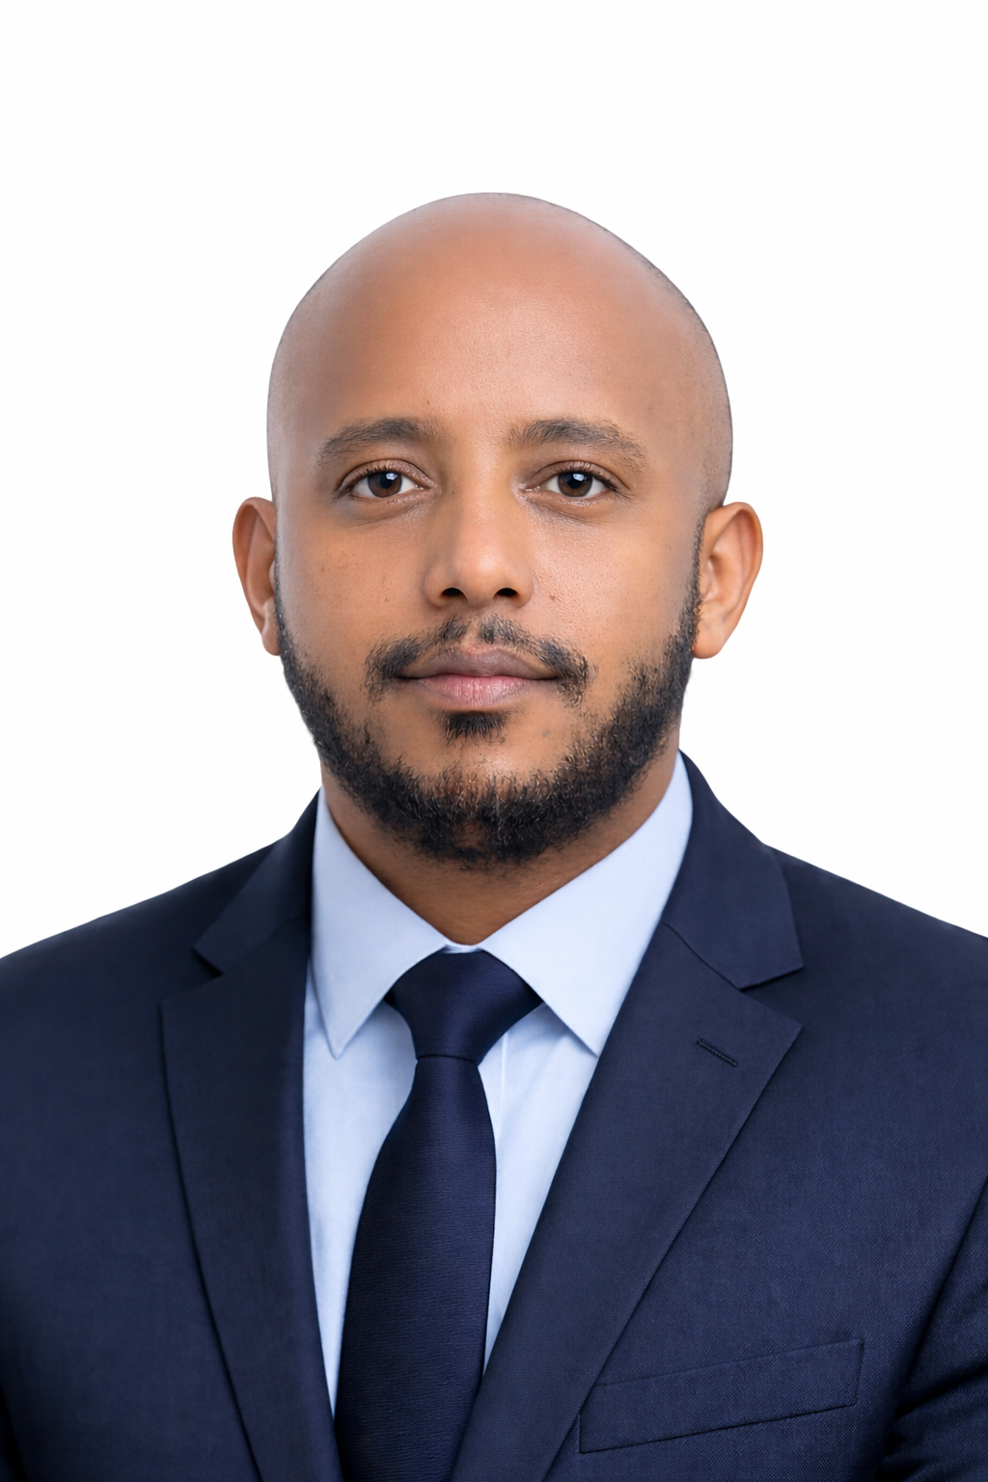
Consultant Profile
Eyoel Netsere Tadesse
Senior Structural Engineer | Water Infrastructure Specialist
Eyoel Netsere Tadesse is a Senior Structural Engineer with over 7 years of specialized experience in water infrastructure design. His expertise includes dam outlet structures, water treatment plants, irrigation networks, and civil engineering supervision. Eyoel has played a pivotal role in designing and overseeing high-profile projects across Ethiopia, collaborating with multidisciplinary teams to ensure that all designs meet rigorous safety and sustainability standards.
He is skilled in structural analysis, seismic design, and technical documentation, with a proven track record in leading projects that contribute to the advancement of Ethiopia's water infrastructure. His leadership in large-scale projects demonstrates a commitment to delivering results that support national growth and sustainability.
BSc in Civil Engineering | MSc in Geotechnical Engineering (ongoing) | Senior Structural Engineer | Water Infrastructure Specialist
Effective structural engineering and infrastructure consultancy requires more than just design expertise. It demands practical judgment, a deep understanding of project behavior, thorough evaluation of safety and sustainability measures, precise reporting, and the ability to translate engineering insights into real-world solutions that enhance the integrity and long-term viability of infrastructure projects.
Education
MSc in Geotechnical Engineering
Addis Ababa Institute of Technology | Addis Ababa, Ethiopia
Expected Completion: 2024
BSc in Civil Engineering
Hawassa University | Hawassa, Ethiopia, 2014
Core Competencies
- Structural Engineering and Design
- Water Infrastructure and Irrigation Systems
- Seismic and Stability Analysis
- Civil Engineering Supervision
- Project Management and Coordination
- Proficient in AutoCAD, ETABS, SAP 2000, MIDAS, Autodesk Civil 3D, Autodesk Revit
- Technical Documentation and Reporting
- Global Sustainability Standards and Climate Resilience
Professional Experience
Senior Structural Engineer
Ethiopian Engineering Corporation (EEC), WES | Addis Ababa, Ethiopia
April 2017 – Present
- Lead the design and supervision of infrastructure projects, including dams, bridges,
- and water treatment plants.
- Contributed to the success of Bole Arabsa Wastewater Treatment Plant, improving
- water management in Addis Ababa.
- Managed project timelines, budgets, and resources to meet safety and quality standards.
- Trained junior engineers and ensured the transfer of best practices in design and
- construction.
Structural Design Team Leader
Ethiopian Engineering Corporation (EEC), WES | Addis Ababa, Ethiopia
January 2023 – Present
- Oversaw structural teams on large-scale infrastructure projects, ensuring design
- integrity and adherence to international standards.
- Led technical evaluations and design reviews for major projects, such as dams and
- wastewater systems.
- Played a key role in securing project funding and resources.
Key Achievements
- Bole Arabsa Wastewater Treatment Plant: Led the successful design and construction of a 30,000 m³/day facility, significantly improving water management for Addis Ababa.
- Ethiopian Engineering Corporation (EEC) Recognition: Honored for outstanding leadership in managing the structural design and construction of the Bole Arabsa Wastewater Treatment Plant.
- Sharma Dam and Kola Dam Projects: Directed the design efforts for these critical infrastructure projects, which enhance Ethiopia's agricultural capacity and water security.
Certifications & Training
- Certified Structural Engineer – Ethiopian Engineers Association (EEC)
- Certificate in Water Infrastructure Design – Addis Ababa Institute of Technology
- Certificate of Completion – Ethiopian Engineering Corporation (EEC) for contributions to the Bole Arabsa Wastewater Treatment Plant
Technical Proficiencies
- Software: AutoCAD, SAP 2000, ETABS, MIDAS, Autodesk Civil 3D, Autodesk Revit
- Project Management Tools: MS Project, Primavera P6
- Programming Languages: Python, MATLAB (for structural analysis and modeling)
Social Responsibility & Volunteering
- Contributed to community development projects focused on water access and irrigation, improving food security for farmers in rural Ethiopia.
Selected Project Experience
- Sharma Dam and Irrigation Project – Senior Structural Engineer / Team Leader
- Kola Dam and Irrigation Project – Senior Structural Engineer / Team Leader
- Wogaye Dam and Irrigation Project – Senior Structural Engineer / Team Leader
Professional Affiliations
- Member, Ethiopian Engineers Association (EEA)
Languages
- English: Excellent (Reading, Writing, Listening, Speaking)
- Amharic: Native proficiency
Contact
- Email: eyoelnetsere@gmail.com
- Phone: +251 91 170 4445
- LinkedIn: https://www.linkedin.com/in/eyoel-netsere-02353b120/
Consultancy Role
- Senior Structural Engineer | Water Infrastructure Specialist

