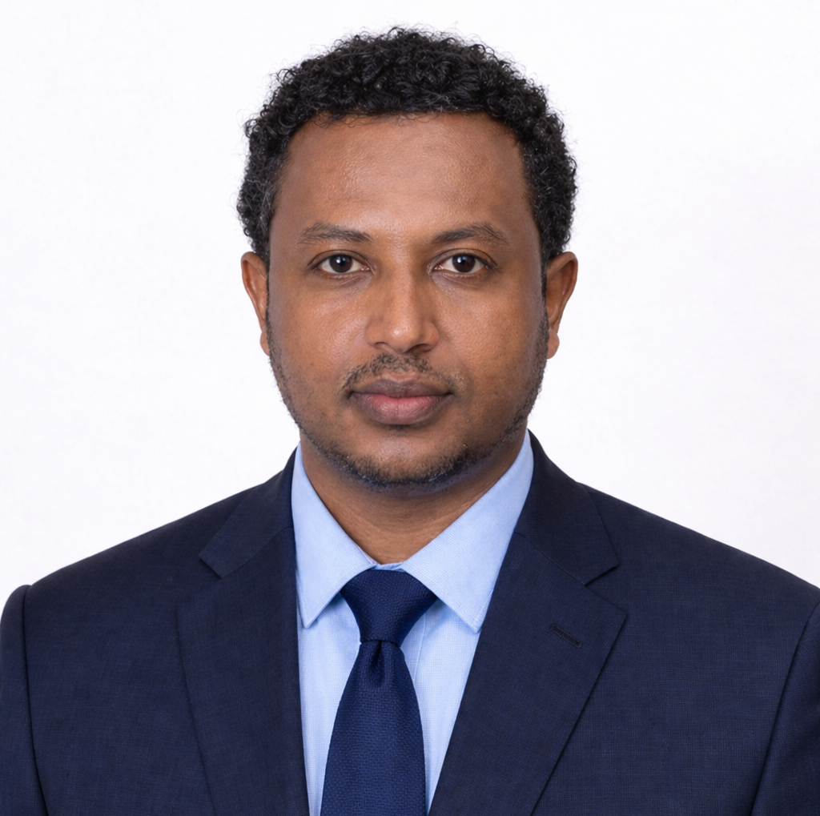 | CONSULTANT PROFILE  Abraham Yoseph Duki  Senior Dam, Geotechnical and Hydraulic Engineer | Project Manager | Team Leader  Senior civil and hydraulic engineer with more than 17 years of professional experience in dam engineering, geotechnical engineering, irrigation development, hydropower studies, construction supervision, contract administration, and multidisciplinary project leadership. His work spans Ethiopia, Rwanda, and Tanzania, with direct experience on large and medium-scale projects financed by the World Bank and the African Development Bank.
MSc in Construction Technology & Management | MSc in Geotechnical Engineering
MBA in Management | BSc in Hydraulic & Water Resources Engineering
Executive Summary
Abraham Yoseph Duki is a senior hydraulic, dam, and geotechnical engineer with strong professional experience in the planning, design, review, and supervision of major water infrastructure projects. His background combines engineering design, dam and irrigation development, geotechnical investigations, construction supervision, project management, and contract administration across public-sector and consulting assignments.
His experience is directly relevant to dam engineering, hydraulic structures, irrigation systems, hydropower pre-feasibility work, foundation design, project coordination, and technical oversight of complex civil works. He has worked on dams, irrigation schemes, bridges, water supply systems, hydropower projects, and major construction assignments in Ethiopia, Rwanda, and Tanzania.
Strong dam and hydraulic consultancy requires not only technical design capacity, but also practical field judgment, geotechnical understanding, multidisciplinary coordination, and disciplined construction and contract follow-up.

Areas of Professional Strength
Abraham's professional profile reflects broad experience in dam design, geotechnical investigations, irrigation engineering, contract administration, construction supervision, project management, hydraulic review, and technical reporting. His assignments include dam and irrigation feasibility studies, detailed design, geotechnical assessment, construction-stage engineering support, and project leadership on nationally significant water and infrastructure projects.
Core Areas of Expertise  - Dam engineering and hydraulic structures  - Geotechnical investigation and foundation design  - Irrigation engineering and water infrastructure development  - Hydropower pre-feasibility and conceptual design support  - Construction supervision and contract administration  - Project management and team leadership  - Engineering reporting, BoQs, drawings, and tender documents  - Survey, geotechnical, and construction quality review |  | Professional Roles  - Senior Hydraulic / Dam Engineer  - Geotechnical Engineer  - Project Manager  - Resident Engineer  - Contract Administration Engineer  - Team Leader  - Design Engineer  - Construction Supervision Engineer
Core Technical and Leadership Strengths
Dam Engineering | Geotechnical Engineering | Irrigation Design | Hydraulic Structures | Hydropower Studies | Project Management | Contract Administration | Construction Supervision | Foundation Design | Spillway Design | Intake Structures | Site Investigations | BoQs & Tender Documents | Engineering Reporting | FIDIC / PPA Experience
Professional Profile
FULL NAME  Abraham Yoseph Duki | CURRENT BASE  Addis Ababa, Ethiopia
CURRENT STATUS  Senior Hydraulic / Dam Engineer, Resident Engineer, Geotechnical Engineer, Project Manager | EMAIL  abrahamy4@gmail.com
PHONE  +251 911 60 69 24 / +251 960 90 50 71 | PROFESSIONAL LICENSES  PPECM/2610 • PRHWRE/293
Education
Addis Ababa University, Ethiopia
February 2025
Master of Business Administration (MBA) in Management
Hawassa University, Ethiopia
April 2019
Master of Science in Civil Engineering (Geotechnical Engineering)
Arba Minch University, Ethiopia
May 2017
Master Degree in Civil Engineering (Construction Technology and Management)
Arba Minch Water Technology Institute, Ethiopia
July 2009
BSc in Hydraulic and Water Resource Engineering
Selected Career Highlights
17+ Years of Progressive Experience  Extensive professional experience in Ethiopia, Rwanda, and Tanzania, with involvement in 33 medium and large-scale projects across design, supervision, geotechnical investigation, and design-build assignments. | Strong International Development Exposure  Worked on projects financed by the World Bank and the African Development Bank, with practical experience using FIDIC and PPA-based contracting approaches.
Broad Multidisciplinary Capability  Brings integrated experience in dam, irrigation, hydropower, water supply, bridge, and building foundation assignments, combining technical design and implementation understanding. | Leadership and Delivery  Has served as project manager, team leader, geotechnical engineer, resident engineer, and senior design engineer in both institutional and project-based consulting environments.

Employment Record
Ethiopian Engineering Corporation
April 2017 - Present
Senior Engineer engaged in dam and headworks processes, including senior hydraulic / dam engineering, resident engineering, geotechnical engineering, and project management responsibilities.
SABA Engineering PLC
February 2023 - Present
Senior Design Engineer Expert supporting dam and irrigation design work, including assignments for the National Irrigation Commission of Tanzania.
YTG Engineering Private Limited Company
October 2023 - April 2025
Geotechnical Engineer on project-based engineering assignments.
Adamso Serbessa General Contractor
August 2019 - May 2023
Geotechnical / Materials Engineer and Project Team Leader.
Ethiopian Design and Construction Supervision Corporation
November 2014 - April 2017
Engineer IV with experience in construction supervision and engineering delivery.
Water Works Design and Supervision Works Enterprise
March 2011 - November 2014
Engineer I contributing to water and infrastructure design and supervision assignments.
China International Water and Energy Corporation
January 2010 - 2011
Consultant's Engineer in early professional assignments.
Experience Relevant to Dam, Geotechnical, and Water Infrastructure Projects
Dam and Hydraulic Design
Participated in feasibility studies, detailed design, preliminary engineering, and design review for earthfill, rockfill, and irrigation dam projects, including spillways, intake towers, diversion works, and appurtenant hydraulic structures.
Geotechnical Engineering and Foundation Design
Led and supported geotechnical investigations, slope stability assessment, borehole logging, drilling supervision, laboratory testing, groundwater review, and foundation recommendations for dams, bridges, and buildings.
Construction Supervision and Contract Administration
Served in site and office-based roles involving measurement certification, payment review, progress reporting, contractor supervision, document review, design modifications, and quality compliance for major infrastructure projects.
Project Leadership and Coordination
Managed multidisciplinary engineering teams, coordinated resources and technical workflows, communicated with clients and stakeholders, and supported procurement, TOR preparation, and tender documentation.
Representative Responsibilities
- Dam site selection, reconnaissance, and preliminary design support  - Spillway, diversion, intake, and outlet structure design  - Geotechnical investigation planning and supervision  - Engineering drawings, BoQs, tender documents, and reports  - Hydraulic and water infrastructure technical review  - Construction monitoring and quality-focused site engineering | - Project management and engineering coordination  - Contract administration and progress certification  - Technical proposal and TOR preparation  - Client communication and stakeholder meetings  - Resource planning and QMS-oriented project delivery  - Software-enabled design, modelling, and reporting support
Selected Project Exposure
Nyarubogo Dam Rehabilitation and Improvement Project, Rwanda
Dam - Geotechnical Design Engineer on a World Bank-financed project involving design revision, geotechnical validation, and hydraulic structure review.
Bezo Dam and Irrigation Feasibility Study and Detailed Design, Ethiopia
Project Manager on a major large-scale irrigation and dam development assignment covering 13,000 ha.
Rift Valley RV-3A Hydropower Project, Ethiopia
Dam Design Engineer supporting hydropower site evaluation, conceptual design, geological assessment, and technical risk review.
Churazo and Muhazi Dam and Irrigation Projects, Tanzania
Hydraulic / Dam Design Engineer on African Development Bank-financed projects including dam structures, spillways, intake towers, and irrigation systems.
Dabus, Tendaho, Rib, Kessem, Gidabo, Kuraz, and Koga Projects, Ethiopia
Progressive roles in design, contract administration, supervision, and technical support on major dam and irrigation programs.
Representative Project Experience
Project | Role | Client / Financier | Relevant Experience
Design Study for Rehabilitation and Improvements of Nyarubogo Dam, Rwanda | Dam - Geotechnical Design Engineer | RAB / World Bank | Assessed dam heightening feasibility, revised hydraulic structures, conducted geotechnical validation, and prepared revised reports, drawings, and BoQs.
Bezo Dam and Irrigation Feasibility Study and Detailed Design, Ethiopia | Project Manager | Irrigation Schemes Development Administration Agency / Ministry of Finance | Led engineering teams, reviewed TORs and proposals, managed design activities, and coordinated large-scale dam and irrigation studies.
Churazo Dam and Irrigation Project, Tanzania | Hydraulic / Dam Design Engineer | National Irrigation Commission / African Development Bank | Worked on site selection, spillway and diversion design, design reporting, geotechnical investigation supervision, and second-stage construction design.
Muhazi Dam and Irrigation Project, Tanzania | Dam Design Engineer | National Irrigation Commission / African Development Bank | Supported design of dam, spillway, intake towers, diversion works, reports, drawings, and application of design criteria.
Dabus Dam Design Project, Ethiopia | Hydraulic / Dam - Irrigation Design Engineer | Ministry of Water, Irrigation & Electricity / World Bank | Managed geotechnical and geophysical investigations, supervised site works, and prepared design reports, drawings, and BoQs.
Tendaho and Rib Dam Construction Projects, Ethiopia | Contract Administration Engineer | Water Sector Institutions / MoFED / AfDB | Handled contract administration, construction progress supervision, design review, quantity take-offs, measurement certificates, and reporting.

Software and Technical Tools
Abraham's software background includes Autodesk Civil 3D, MiDAS GTS NX, Revit, CADDAM, Staad Pro, AutoCAD, ArchiCAD, SAP 2000, WaterCAD, GeoStudio, Bentley Inroads, Surfer, ArcGIS, Global Mapper, Shake 1-D, MIDAS Soil Works, Plaxis 3D, Primavera, MS Project, SQL, BIM applications, SPSS, Matlab, and general engineering productivity tools.
Training, Membership, and Professional Development
His professional development includes project management, geotechnical laboratory practice, soil testing and foundation engineering, AutoCAD, contract law and administration, geohazard and landslide protection, earthquake engineering, building information modelling, and advanced geotechnical and structural analysis training. He is also associated with relevant professional bodies including ISSMGE, EEGA, EACE, ASCE, EOS, and construction technology and management professional associations.
Professional Value in Water Infrastructure Consultancy
Abraham Yoseph Duki offers a valuable combination of dam engineering, geotechnical expertise, hydraulic design capability, field supervision experience, project management discipline, and practical contract administration knowledge. His background is especially well suited to dam and irrigation consultancy assignments that require strong technical design judgment together with implementation awareness and multidisciplinary coordination.
Contact
Email: abrahamy4@gmail.com
Phone: +251 911 60 69 24 / +251 960 90 50 71
Location: Addis Ababa, Ethiopia
Consultancy Role: Senior Dam, Geotechnical and Hydraulic Engineer / Project Manager / Team Leader

